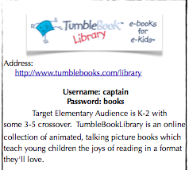Macintosh HD:Users:loriemadriz:Desktop:Captura de pantalla 2013-09-11 a las 6.23.42 PM.png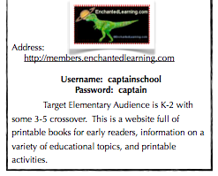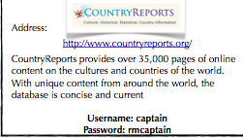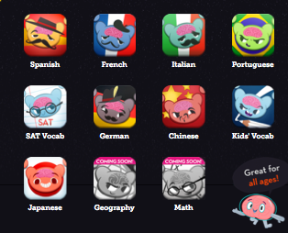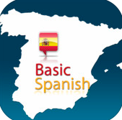

**1. Go to the School District of Clayton website.**

**2. Choose Captain Elementary.**

**3. Go to Staff and choose Specialist- Lorie Madriz – Spanish.**

**4. Click on Internet resources I have created.**

**5. Look for QUIA activities for your child’s level.**

**2.**

Search for worksheets in Spanish and more. ☺

<http://esp.brainpop.com>

**Username:captainschool**

**Password:cgm**

**Pass**

This site is K-5 and is in Spanish. It is similar to the English version that some students have seen in class before.

🙞 🙜

Here are some ideas for extra practice for your child (and for you) to practice Spanish at home.

The information on this site includes recipes from each country presented. ☺

Check for books in Spanish. These talking picture books are awesome! ☺

🙞 🙜

|  |
| --- |
| **Spanish Online**  Resources & Apps  for Smart phones and other devices |

**Apps for iphone**

**Mindsnacks Spanish**

**Mindsnacks Spanis h**

Learn Spanish Vocabulary by Hello-Hello

**Learn Spanish Free by Bravolo**

**Duolingo Spanish**

**Check the itunes store or google play for other free or inexpensive apps to put onto your ipad, iphone, ipod touch, or other smart device.**

**Some of them are quite good and very interactive.**

**Be sure to let me know when you find new ones!**

**☺ Señora Madriz**

[loriemadriz@claytonschools.net](mailto:loriemadriz@claytonschools.net)